# Lesson 4, Step 2: Space Analysis Integration

Let's connect what you've learned about organizing portfolios with the design principles you'll apply in your future work. This section builds on the basic zoning and documentation concepts we covered earlier, weaving them into a deeper understanding of space. For those of you pursuing interior design, your skill in analyzing and documenting spaces isn't mere paperwork—it forms the bedrock of your design choices and will distinguish you when you tackle complex projects down the road.

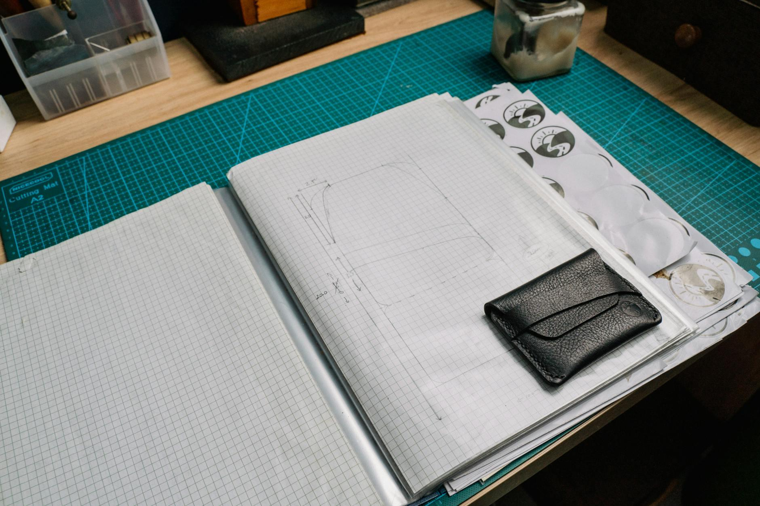

Fig.1 (Anna Tarazevich on [Pexels](https://www.pexels.com/photo/5962640/), 2025) Functional zoning analysis transforms abstract spaces into purposeful design areas, creating the foundation for all subsequent design decisions.

### Functional Zoning

When you step into a well-designed space, everything feels right—each element seems perfectly placed. This feeling never happens by chance:

1. Spot the main activities happening in a space (sleeping, working, dining, relaxation)
2. Draw a simple floor plan and highlight different functional zones using colored overlays:

* Living/relaxation areas (blue)
* Working/activity zones (yellow)
* Storage areas (green)
* Dining/eating spaces (orange)

Consider a studio apartment where every inch counts. The distinction between a cluttered, confusing layout and one that feels open often boils down to thoughtful zoning. When you show clients how you've maximized their tight space through clever zoning, they'll immediately recognize your expertise.

**Try This when reimagining versatile living areas:** Look at an open-plan space that needs to accommodate cooking, dining, and relaxation. Consider how furniture placement, lighting, and even floor treatments might create visual boundaries without actual walls. This groundwork will set you up for the more nuanced multi-functional analysis you'll tackle during your HNC studies, where you'll incorporate building codes and accessibility requirements into your zoning decisions. Take photos of effective zoning in spaces you visit this week. Sketch a quick bubble diagram of your favorite example.

### Measurement and Documentation

After establishing your functional zones, exact measurements become your design vocabulary. They turn abstract ideas into tangible possibilities that clients can visualize and contractors can execute. Skip this crucial step, and even your most brilliant concepts remain just that—concepts.

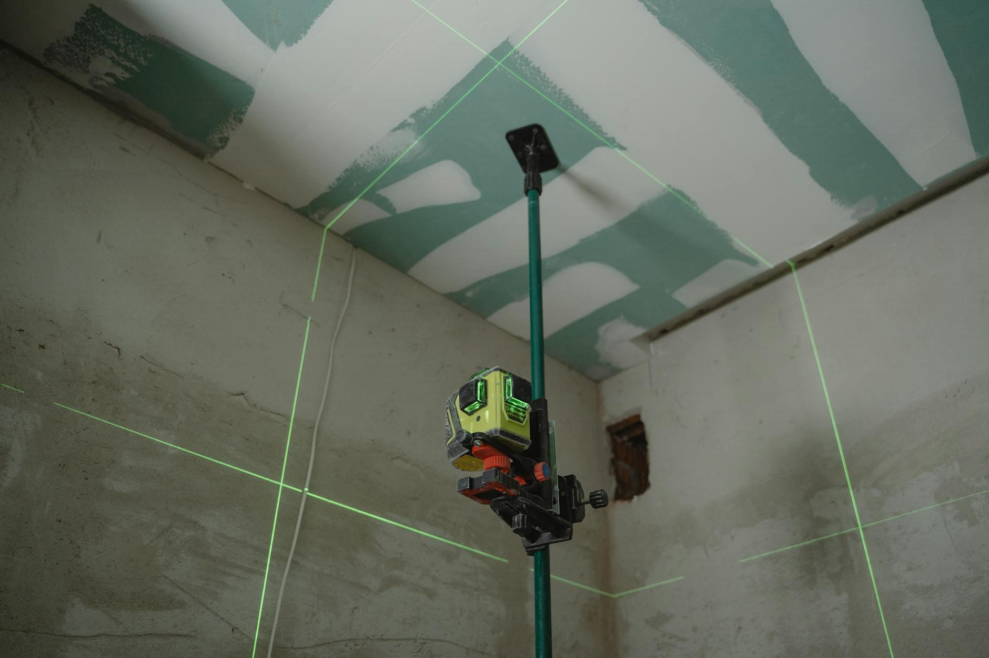

Fig.2 (Tima Miroshnichenko on [Pexels](https://www.pexels.com/photo/6473973/), 2025) Accurate measurement documentation creates the bridge between creative vision and practical implementation, ensuring designs can be properly executed.

Measurements reveal stories about possibilities and constraints that shape every design choice:

* Room dimensions determine if that dream sectional sofa will fit or become an expensive mistake
* The interplay between fixed elements creates opportunities for innovative solutions
* Window positions impact everything from furniture arrangement to mood as daylight shifts
* Vertical space often contains untapped potential that can transform a cramped room into an airy one

The path from basic measurements to rich spatial understanding rarely follows a straight line. You'll find yourself revisiting spaces with fresh perspective as your expertise grows. What seems like a simple hallway measurement today might spark a clever storage solution tomorrow. This back-and-forth process of observing, documenting, and reinterpreting sets thoughtful designers apart from those who simply decorate.

### Circulation Analysis

With zones established and measurements recorded, we need to think about how people actually move through the space. This movement goes beyond getting from point A to point B—it creates an experience that should feel natural and enhance each area's purpose. Even the most stunning design falls flat with poor circulation.

Ever walked into a beautifully decorated room that somehow feels awkward to navigate? That's a circulation problem:

1. On your floor plan, draw arrows to mark:

* Primary pathways (used frequently)
* Secondary routes (occasional use)
* Door swing arcs (the space doors need to open fully)

1. Spot any pinch points (narrow areas) or awkward transitions
2. Examine how circulation patterns affect the functionality of different zones

**Why this Matters** When you get circulation right, people experience spaces effortlessly—they simply flow naturally. This subtle comfort factor often determines whether clients love or merely tolerate your designs, particularly when addressing accessibility needs.

**Try This when exploring your daily environment:** Watch your own movement patterns at home for one day. A novice might simply draw arrows showing the main path from a door to a sofa. A deeper analysis would consider how multiple people might navigate the space simultaneously and identify potential bottlenecks. In your HNC, you'll develop these into more sophisticated circulation studies that incorporate accessibility requirements, emergency exit regulations, and universal design principles. Jot down which areas feel most comfortable to move through and why.

## Practical Application



Fig.3 (Alena Darmel on [Pexels](https://www.pexels.com/photo/7641857/), 2025) Effective space analysis presentations combine multiple analytical layers to tell a complete story about how a space functions and feels.

### Creating a Basic Space Analysis

Your space analysis combines several layers that work together to tell the full story of the design envelope—the physical boundaries and characteristics that influence design possibilities:

1. Identify and evaluate the relationships between different functional zones
2. Look at how natural and artificial light affects the usability of different areas
3. Assess how circulation patterns enhance or detract from the space's functionality
4. Evaluate fixed elements as either limitations or opportunities for design solutions
5. Consider how the existing space supports or hinders its intended functions

Think of these elements as detective work—each layer uncovers new clues about the design envelope. Your zoning analysis might reveal a perfect spot for a home office, but your light analysis shows it's too dark by afternoon. Your circulation study might indicate that placing a dining table in one location creates a traffic jam. This layered understanding lets you make confident recommendations that clients will trust.

**Try This when visiting spaces that serve multiple functions:** Picture analyzing a small retail space. How would you zone it to include display areas, a checkout counter, and perhaps a changing room? Think about how customer flow affects buying behavior. This basic grasp of commercial spatial planning will provide groundwork for the more detailed analysis in your HNC studies, where you'll incorporate commercial building codes, accessibility requirements, and retail-specific design considerations. Sketch a quick bubble diagram of your observations. Identify one element that could improve the overall flow.

### Identifying Spatial Limitations

**[Figure Fig 4: No suitable image found]**

[Image: Before/after comparison of a challenging space transformation, showing how design solutions addressed awkward corners, limited natural light, and restricted dimensions. Caption: "Fig 4: Creative problem-solving transforms spatial limitations into design opportunities, often resulting in the most innovative solutions."]

The most impressive designers aren't those with unlimited budgets—they're the ones who transform challenges into signature features. Understanding spatial limitations forms a key part of the design envelope:

1. Document challenging features:

* Awkward corners or angles
* Insufficient dimensions for standard furniture
* Limited natural light
* Fixed elements that restrict options

1. Create a simple two-column list:

* Column 1: Limitation (e.g., "Narrow entrance")
* Column 2: Impact (e.g., "Restricts furniture delivery options")

**Over to you**: Start thinking about how these elements affect the feeling of the space. Does a low ceiling make a room feel intimate or cramped? Does an awkward corner create an interesting focal point opportunity or disrupt the flow? This introduction to spatial quality—how a space feels beyond just how it functions—will prepare you for the deeper analysis of positive and negative space you'll explore in your HNC studies.

The truth is that unlimited options can actually stifle creativity. The constraints you document aren't obstacles—they're the boundaries of your design envelope that focus your creative problem-solving and frequently lead to the most innovative, memorable design solutions. The space analysis skills you're developing now will directly shape the more detailed technical drawings, design solutions, and understanding of building regulations and ergonomics you'll create in your HNC program.